**NAME : RAJVARDHAN REDDY NANDYALA**

**REG-NO : 180905093**

**SEC : B – B1 , ROLL-NO:19**

**P1)**

def add(x, y):

return x + y

def subtract(x, y):

return x - y

def multiply(x, y):

return x * y

def divide(x, y):

return x / y

print("Select operation.")

print("1.Add")

print("2.Subtract")

print("3.Multiply")

print("4.Divide")

while True:

choice = input("Enter choice(1/2/3/4): ")

if choice in ('1', '2', '3', '4'):

num1 = float(input("Enter first number: "))

num2 = float(input("Enter second number: "))

if choice == '1':

print(num1, "+", num2, "=", add(num1, num2))

elif choice == '2':

print(num1, "-", num2, "=", subtract(num1, num2))

elif choice == '3':

print(num1, "*", num2, "=", multiply(num1, num2))

elif choice == '4':

print(num1, "/", num2, "=", divide(num1, num2))

break

else:

print("Invalid Input")

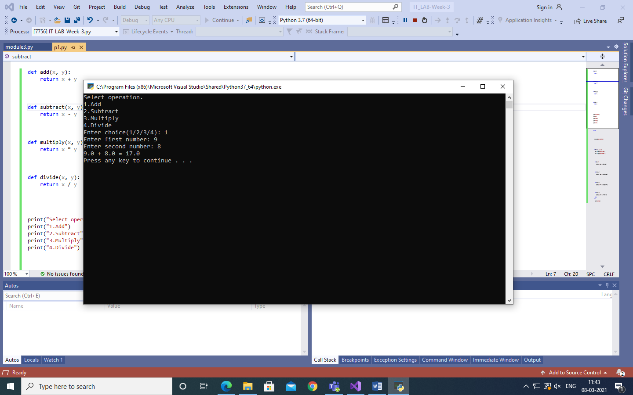

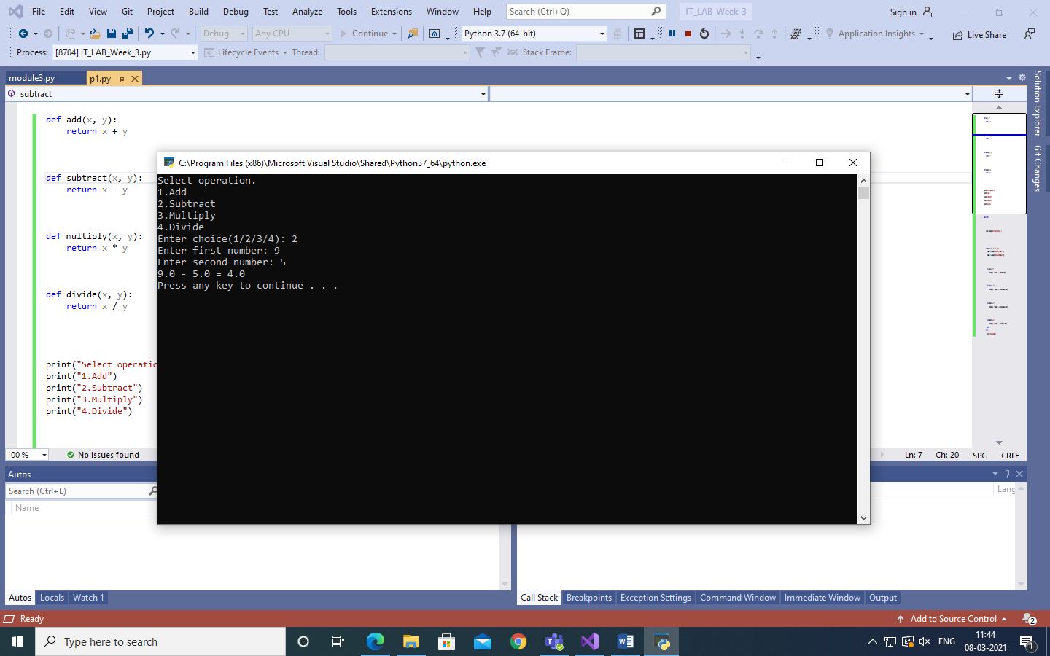

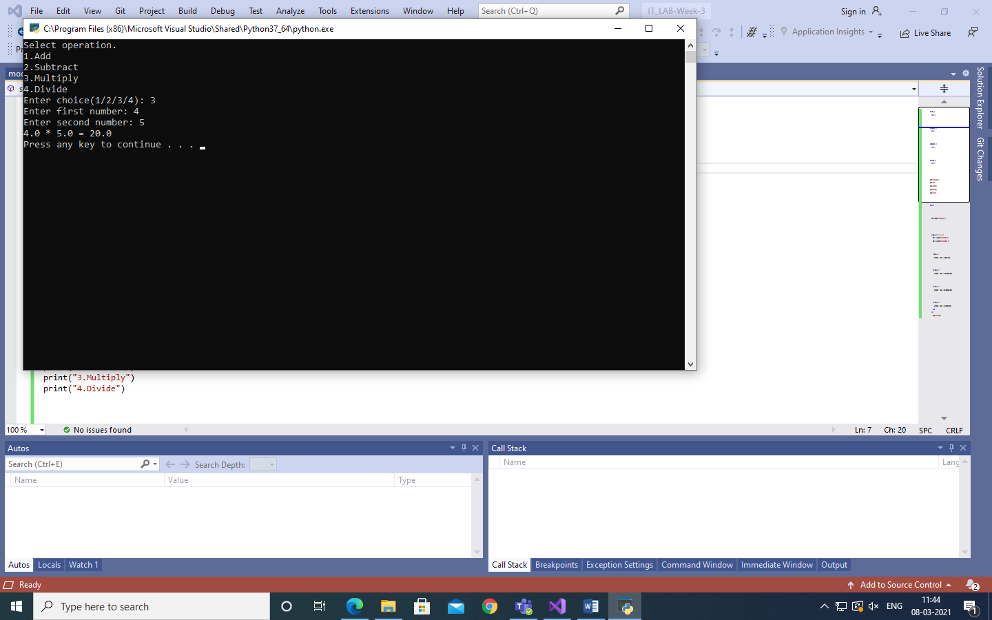

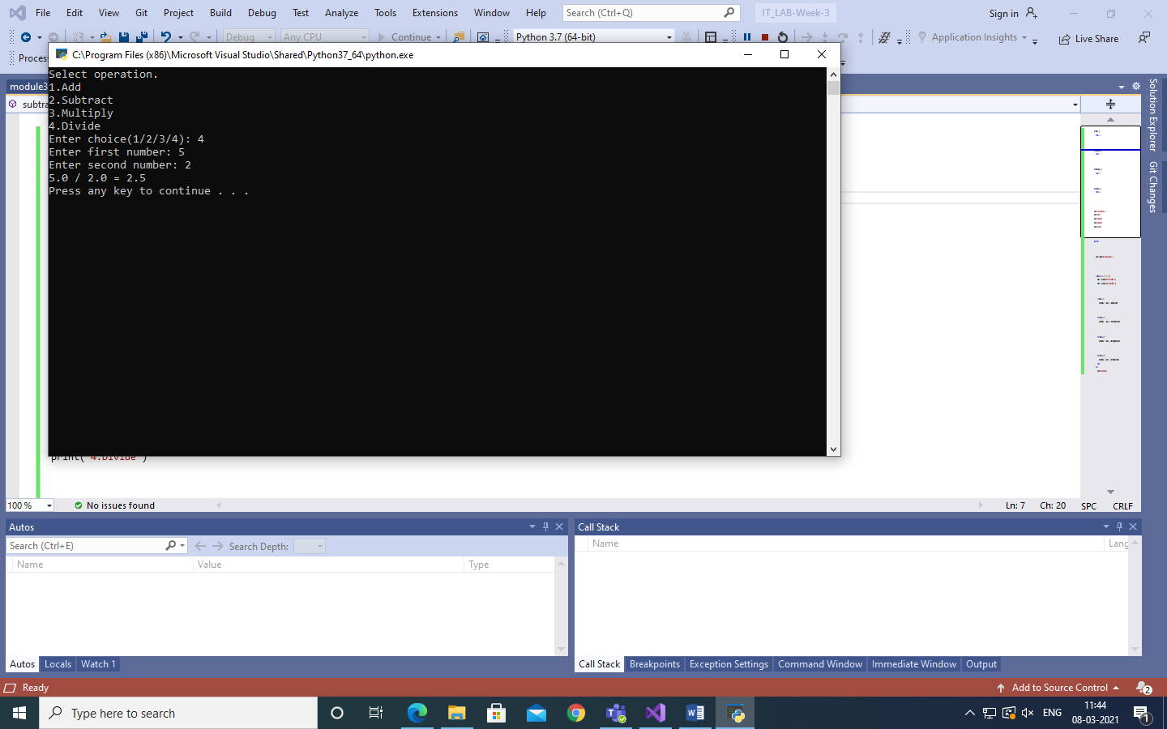

**P2)**

f2=open("p2-initial.txt","w")

with open("p2-final.txt","r") as f1:

data=f1.read()

data_1=data[::-1]

f2.write(data_1)

f1.close()

f2.close()

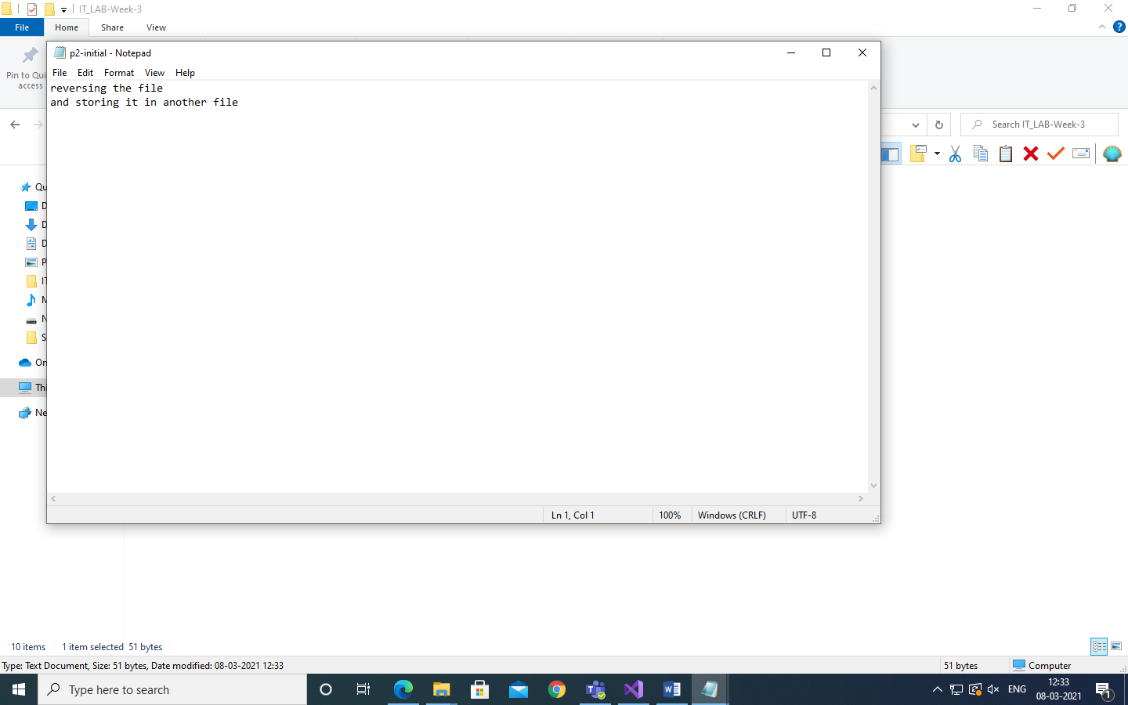

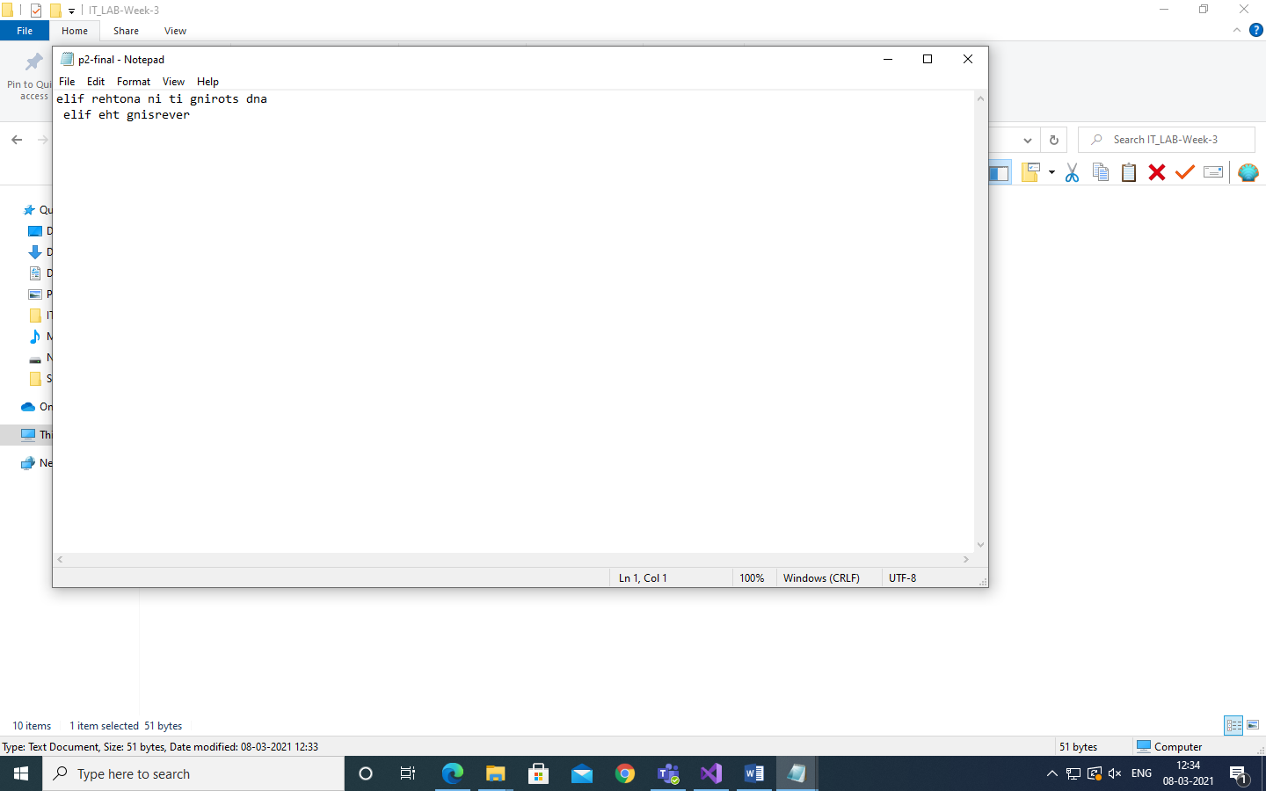

**P3)**

def binarySearch(arr,start,end,key):

if end >= start:

mid =start+(end-start)//2

if arr[mid]==key:

return mid

if arr[mid] > key:

return binarySearch(arr,start,mid-1,key)

else:

return binarySearch(arr,mid+1,end,key)

return -1

n = int(input('Enter array size:'))

print('Enter the array elements:')

arr = list(map(int, input().split()))

arr_len=len(arr)-1

key=int(input('Enter element to search:'))

result=binarySearch(arr,0,arr_len,key)

if result == -1:

print('Element not found')

else:

print('Element found at {}'.format(result))

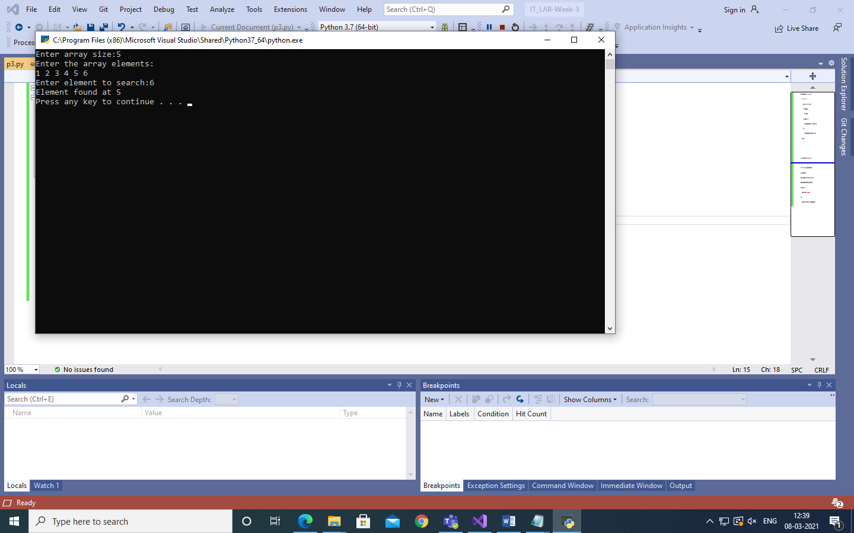

**P4)**

s1 = input("Enter String:")

print("String before sorting : " + str(s1))

s2 = ' '.join(sorted(s1.split()))

print("String after sorting : " + str(s2))

